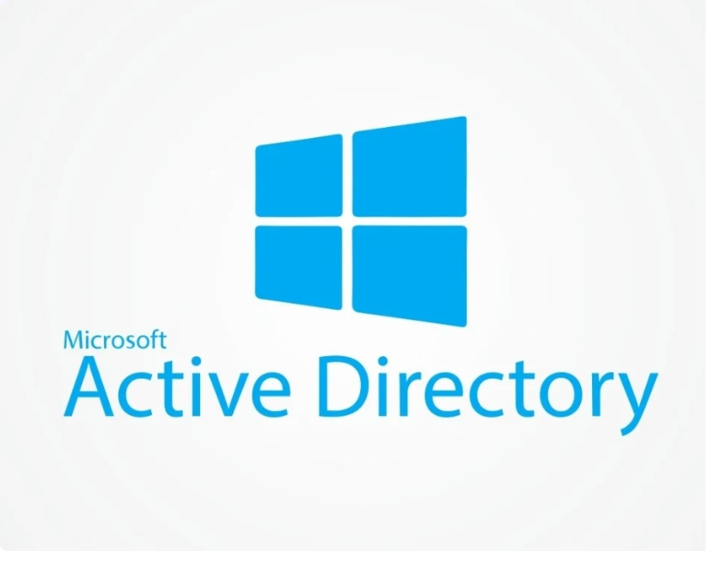

Configuring Active Directory (On-Premises) Within Azure

This tutorial outlines the implementation of on-premises Active Directory within Azure Virtual Machines.

Environments and Technologies Used

- Microsoft Azure (Vitual Machine/Computer)
- Remote Desktop
- Acitive Directory Domain Services
- Powershell

Operating System Used

- Windows Server 2022
- Windows 11

High-Level Deployment and Configuration Steps

- Create Resources
- Ensure Connectivity between the client and Domain Controller
- Install Active Directory
- Create an Admin and Normal User Account in AD
- Join Client-1 to your domain (myadproject.com)
- Setup Remote Desktop for non-administrative users on Client-1
- Create additional users and attempt to log into client-1 with one of the users

Deployment and Configuration Steps

Setup Resources in Azure

Create the Domain Controller VM (Windows Server 2022) named “DC-1”:
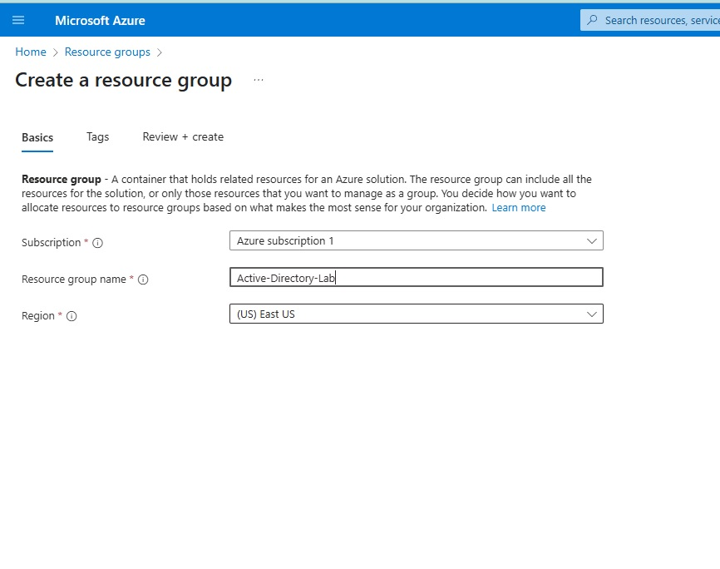
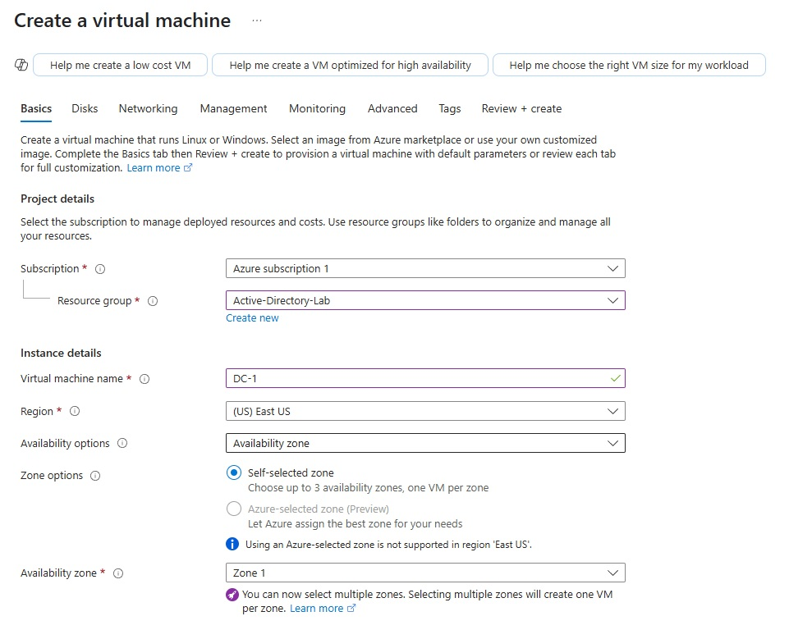

Create the Client VM (Windows 10) named “Client-1”. Use the same Resource Group and Vnet that was created in previous step:
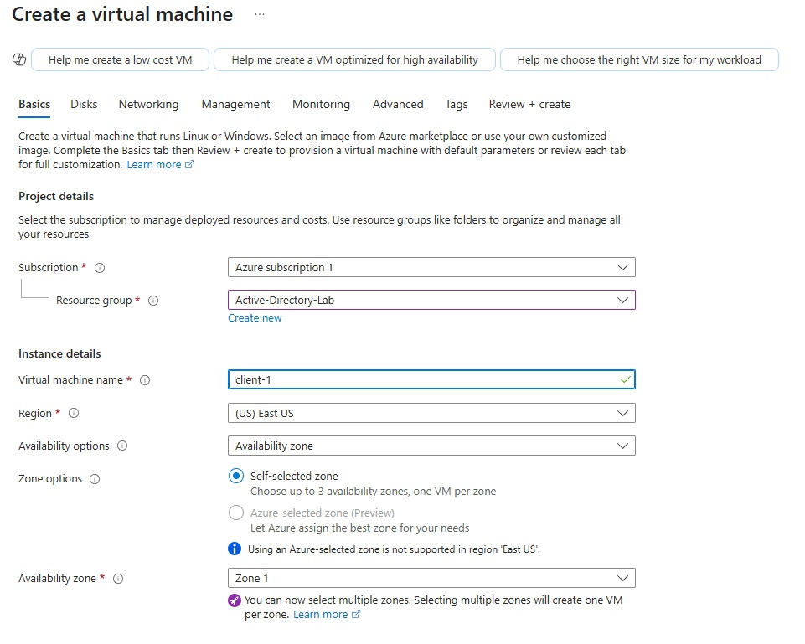
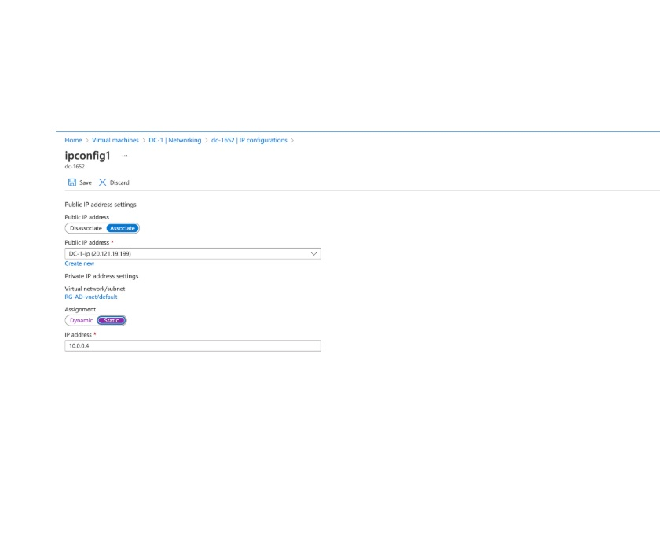
Set Domain Controller’s NIC Private IP address to be static:

Ensure Connectivity between the client and Domain Controller
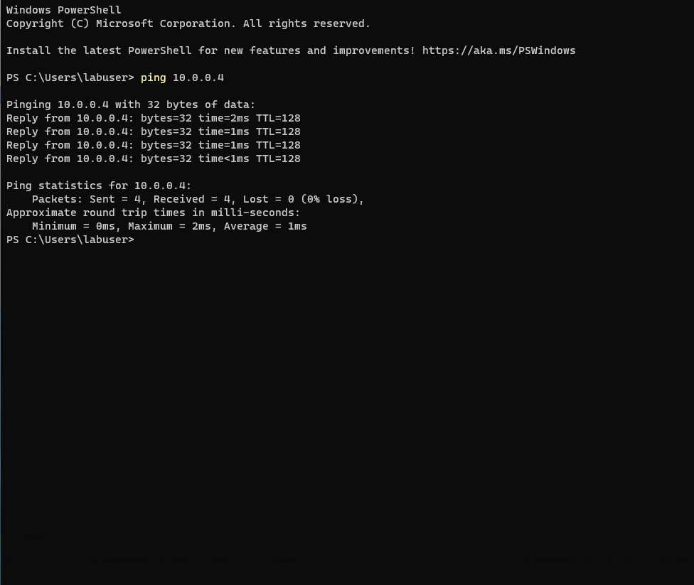
Login to Client-1 with Remote Desktop and ping DC-1’s private IP address with ping -t (perpetual ping):

Install Active Director

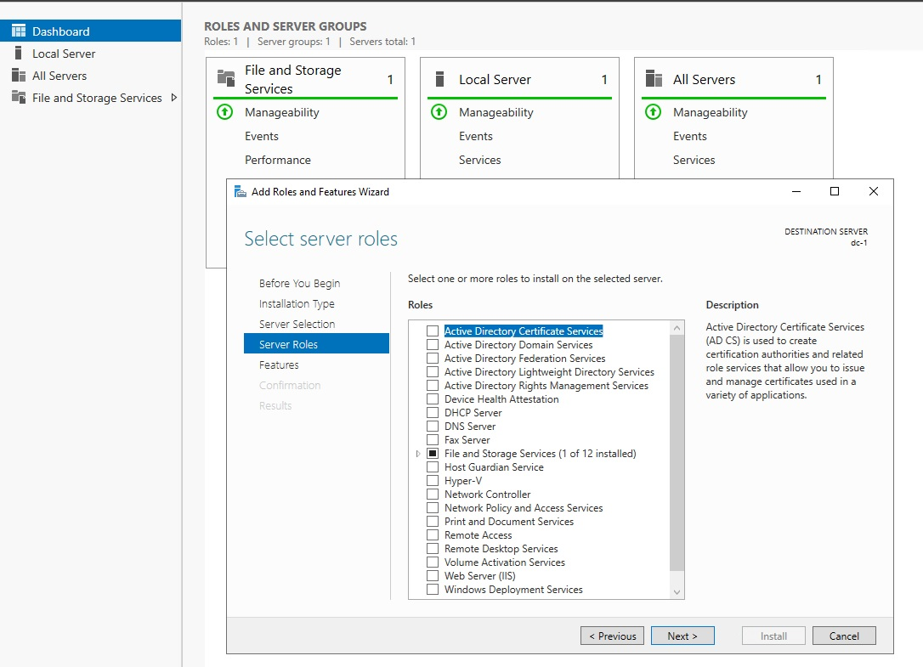
Login to DC-1 and install Active Directory Domain Services:

Promote as a Domain Controller:
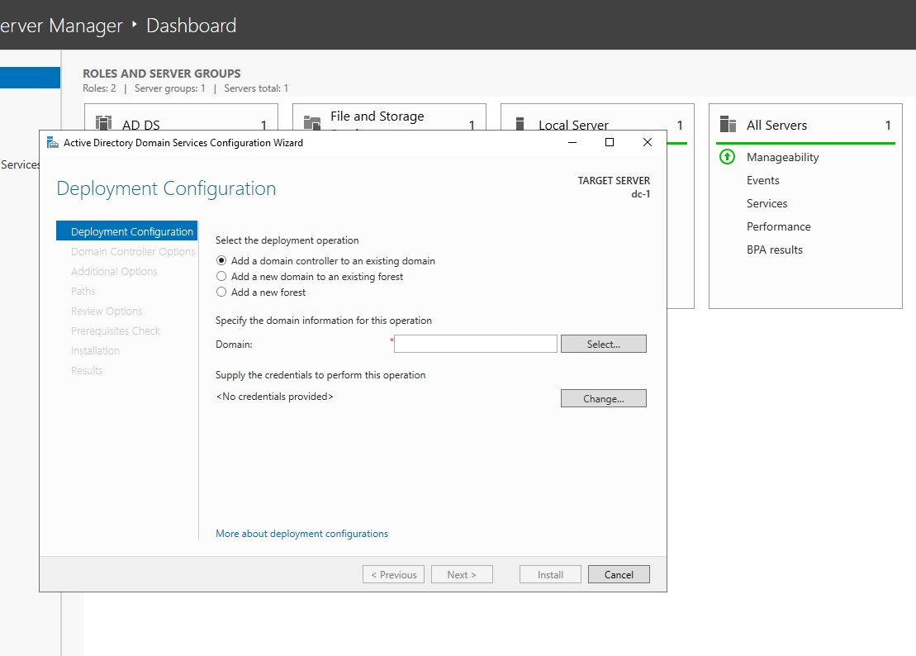

Setup a new forest as mydomain.com (can be anything, just remember what it is)

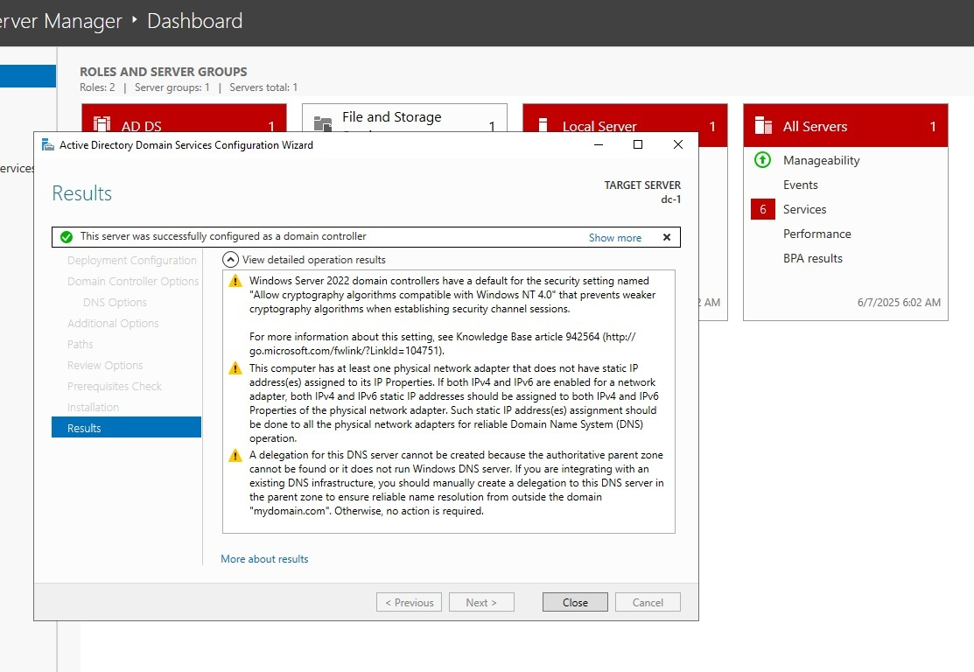

Restart and then log back into DC-1 as user: mydomain.com\labuser:
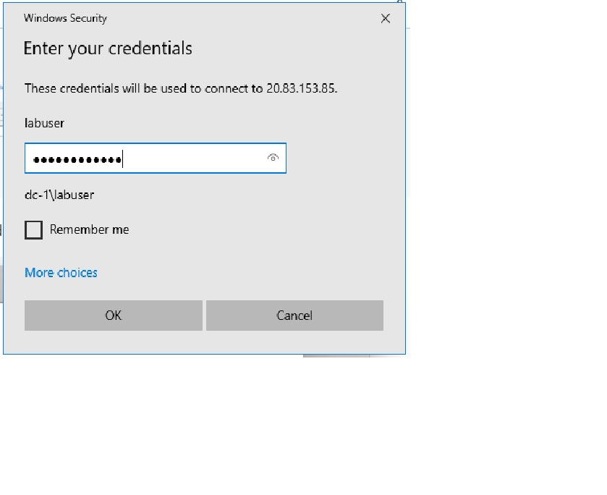

Create an Admin and Normal User Account in AD
In Active Directory Users and Computers (ADUC), create an Organizational Unit (OU) called “_EMPLOYEES” and another one called "_ADMINS":
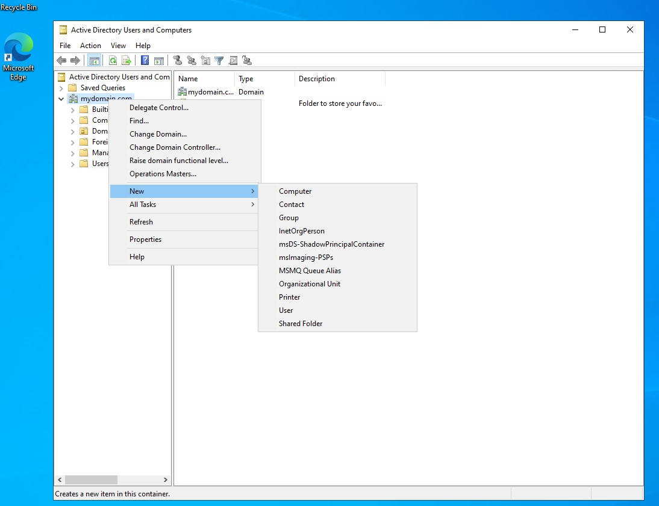

Create a new employee named “Jane Doe” with the username of “jane_admin”:
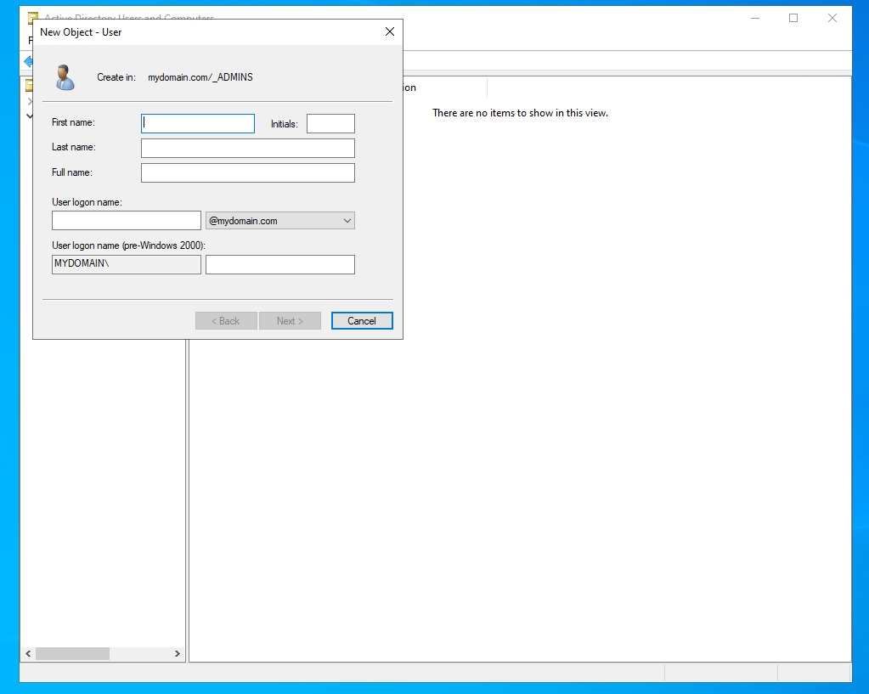

Add jane_admin to the “Domain Admins” Security Group:
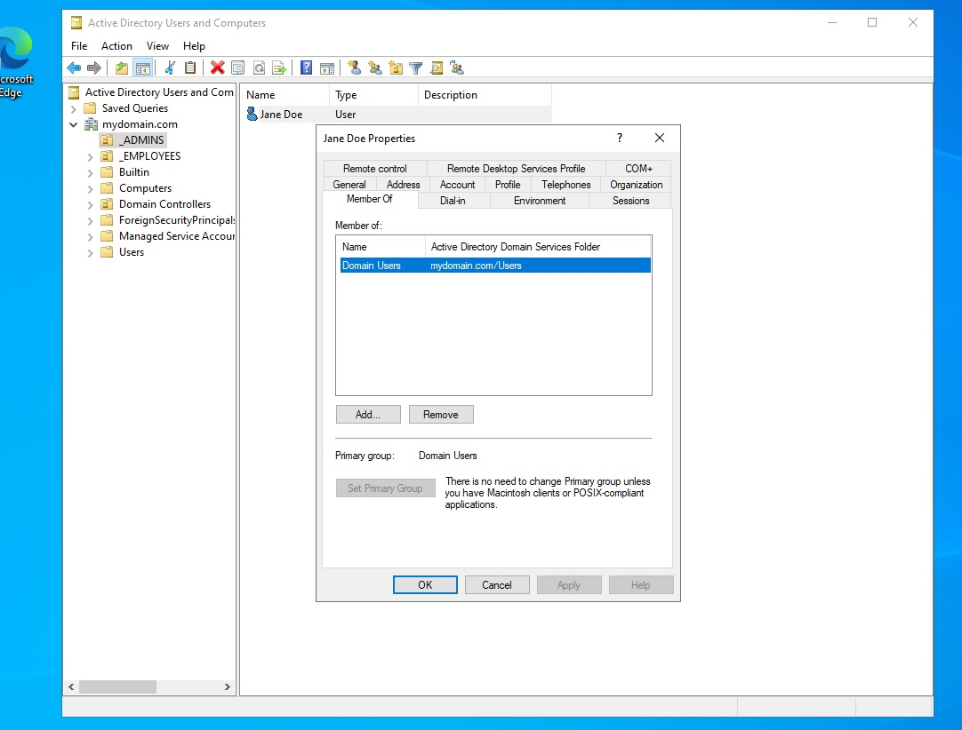

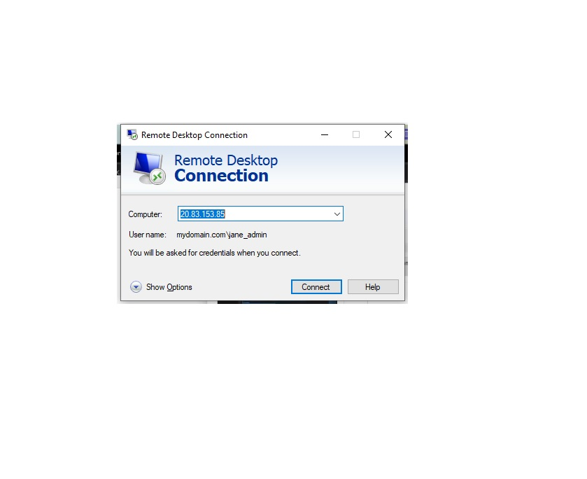
Log out/close the Remote Desktop connection to DC-1 and log back in as “myadproject.com\jane_admin”. Use jane_admin as your admin account from now on:

Join Client-1 to your domain (mydomain.com)
From the Azure Portal, set Client-1’s DNS settings to the DC’s Private IP address:
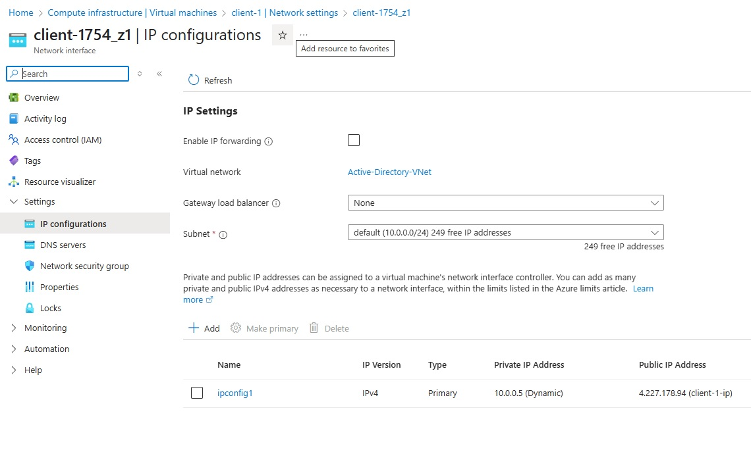

From the Azure Portal, restart Client-1.
Login to Client-1 (Remote Desktop) as the original local admin (labuser) and join it to the domain (computer will restart):
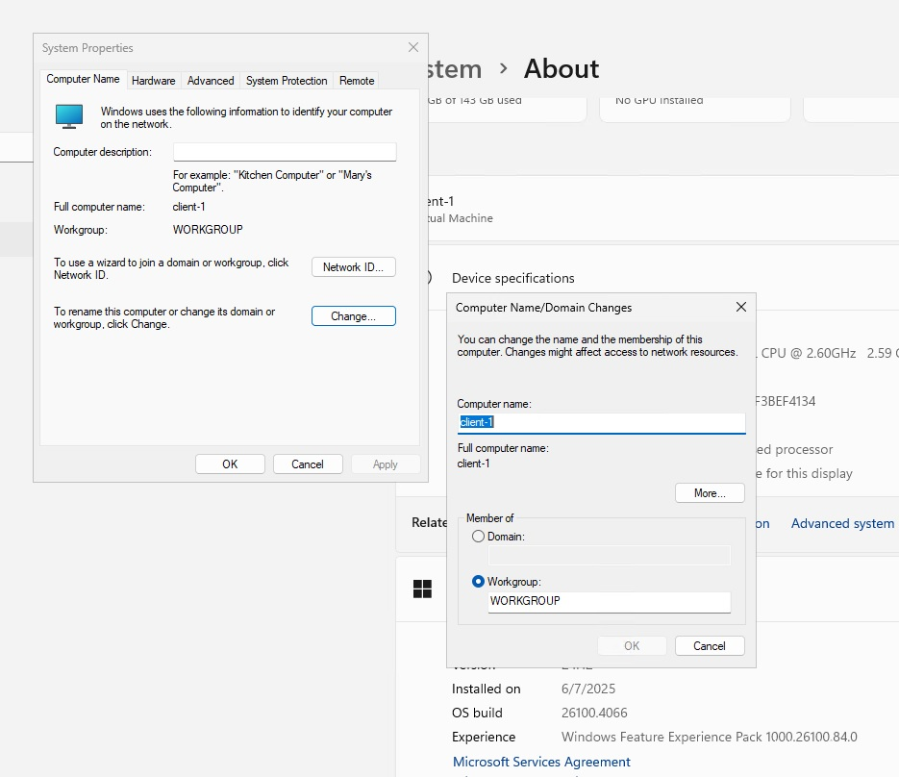

Login to the Domain Controller (Remote Desktop) and verify Client-1 shows up in Active Directory Users and Computers (ADUC) inside the “Computers” container on the root of the domain.

Create a new OU named “_CLIENTS” and drag Client-1 into there:
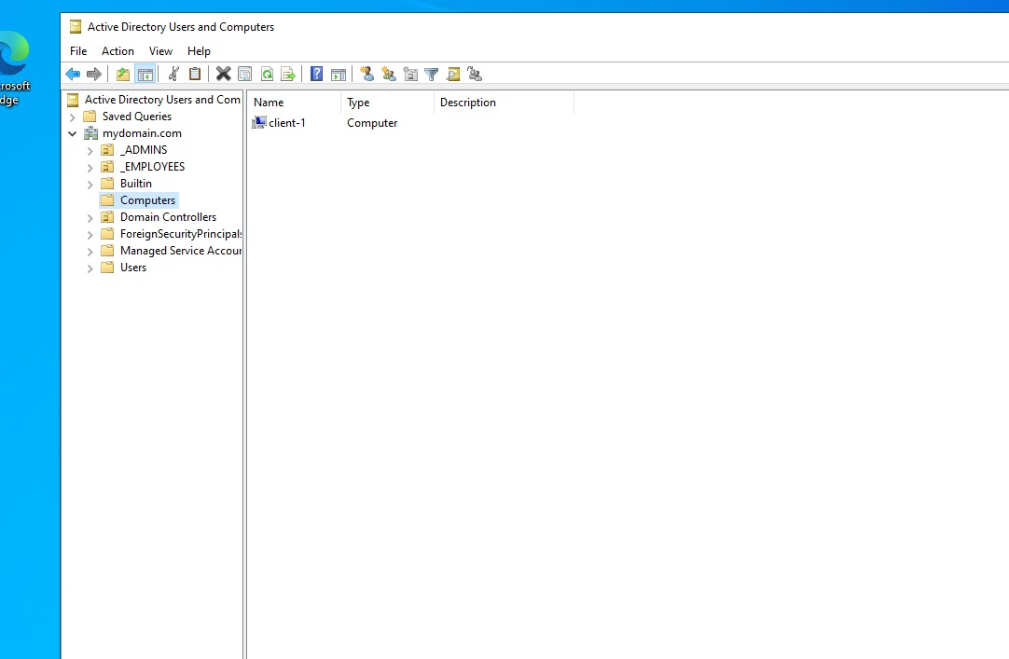

Setup Remote Desktop for non-administrative users on Client-1
Log into Client-1 as mydomain.com\jane_admin and open system properties.
Click “Remote Desktop”.
Allow “domain users” access to remote desktop.
You can now log into Client-1 as a normal, non-administrative user now.
Normally you’d want to do this with Group Policy that allows you to change MANY systems at once (maybe a future lab):
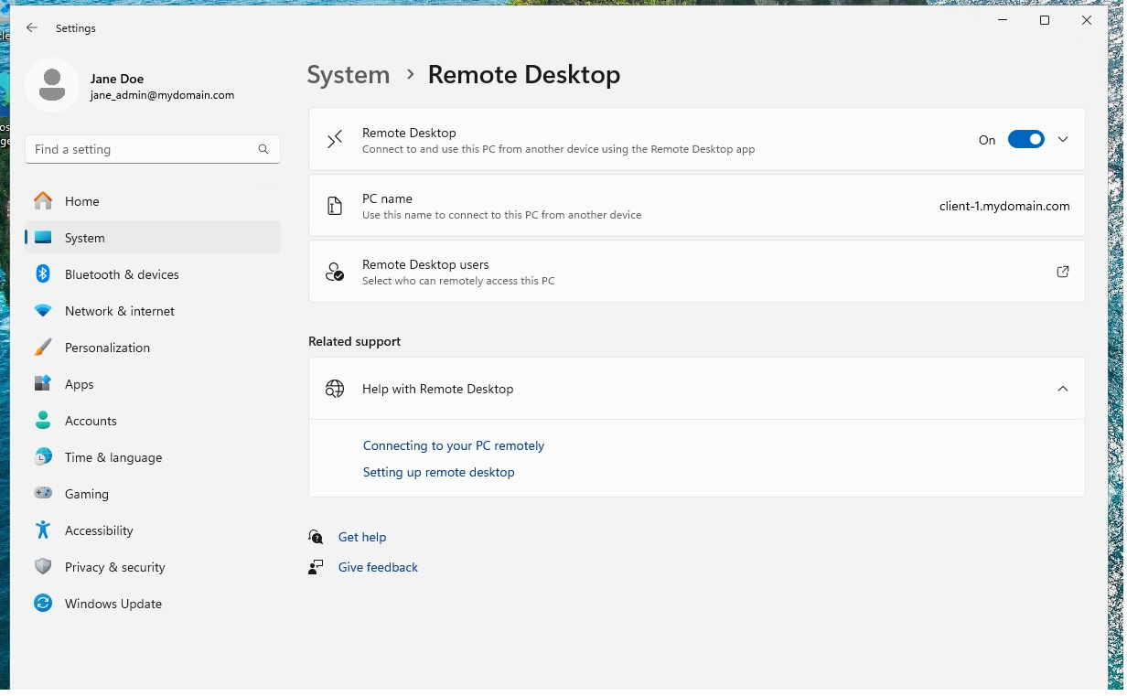

Create a bunch of additional users and attempt to log into client-1 with one of the users
Login to DC-1 as jane_admin
Open PowerShell_ise as an administrator.
Create a new File and paste the contents of this script (https://github.com/Xinloiazn/configure-ad/blob/main/adscript.ps1) into it:
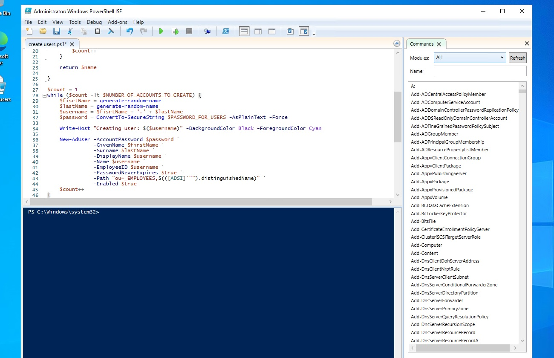

Run the script and observe the accounts being created:
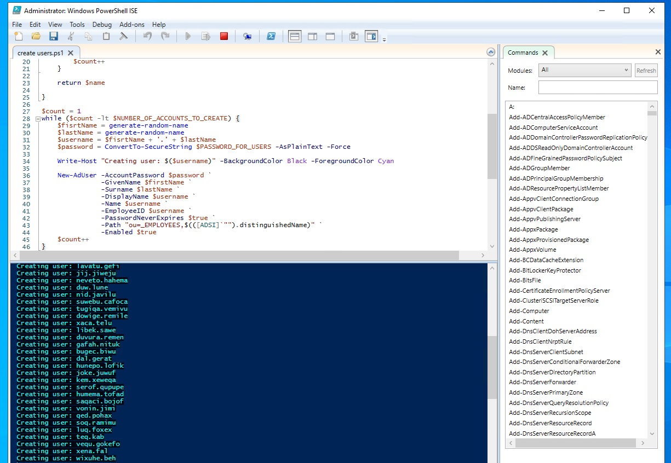

When finished, open ADUC and observe the accounts in the appropriate OU and attempt to log into Client-1 with one of the accounts (take note of the password in the script):

